Your name: ____________________________________

In class, we’ve been talking about how we start to estimate the probability that certain data comes from specific populations. The rarest situation (meaning we rarely have this in real life) is when we know both the mean and the standard deviation of the population we are checking against. Because we know so much about our comparison population, Z-tests are the simplest analysis to run. Although stats programs can run them, we’re just going to practice them step by step.

PART A: Another Z-Test Using Excel to Assist Us (Download file: Pizza.xlsx)

Imagine that in New York, the price of a plain slice of cheese pizza is normally distributed around a mean of $2.75, with a standard deviation of $0.25 (these are population values). A pizza-nerd collects data from 397 randomly selected pizzerias and submits them to a popular NY pizza dataset.
We are going to determine the probability (i.e., the likelihood) that this pizza-nerd would have found this distribution of pizza prices if he actually traveled randomly through New York.
- Write out the null hypothesis.
- Write out the alternative hypothesis.
- Is the hypothesis: ☐ non-directional ☐ directional

- What test should you use? (be specific!)
e) Which of the following did you select when running your analysis?
☐ ≠ ☐ > ☐ <
- Using the appropriate formulas and Excel to assist you, show your work to calculate the Z-statistic

Z-s
Z-Statistic for your sample data: __________
Probability of finding that z-statistic fi the null hypothesis were true?
(one-tailed): p = ________
(two-tailed): p = ________

- Does the sample fall within the critical region (i.e., the tails)?  Note: For α = .05 (two-tailed), the critical z-value is +/- 1.96. For one-tailed, α = .05, the critical z-value is: -1.645; |  |  |  | ☐ Yes ☐ No
- Should the researcher reject the null hypothesis? |  |  |  | ☐ Yes, reject the null ☐ No, retain the null

PART B: PHYSICS PROFESSOR DATA (download PhysicsProfData.csv from Moodle)
Over the next two weeks we will be learning how to run and report a variety of t-test analyses drawn from different fictional and real datasets. First, we’re going to run another rare type of analysis, the Single-Sample T-Test. This is very similar to the Z-tests we have been running; however, we use the T-distribution when we know the mean of our comparison population but DON’T know the standard deviation.

1. Single/One Sample T-Test Problem
A physics midterm exam used a standard test format that is used by other physics professors in the same college. The instructor in the class wants to know whether midterm exam performance for his class is comparable to midterm exam performance for students who took the course during the previous year, but he has only the overall mean score (72) and not the individual scores for the students in the previous year’s class. He can compare his class to the previous year’s class by using a one-sample t-test (also known as a single-sample t-test).

Load the file PhysicsProfData.csv (available on Moodle) into JASP.

- Write out the null hypothesis.
- Write out the alternative hypothesis.
- Is the hypothesis:
☐ non-directional ☐ directional

- What test should you use? (be specific!)
e) Which of the following did you select when running your analysis?
☐ ≠ ☐ > ☐ <

- Click on the “t-test” tab and select the “one sample t-test”
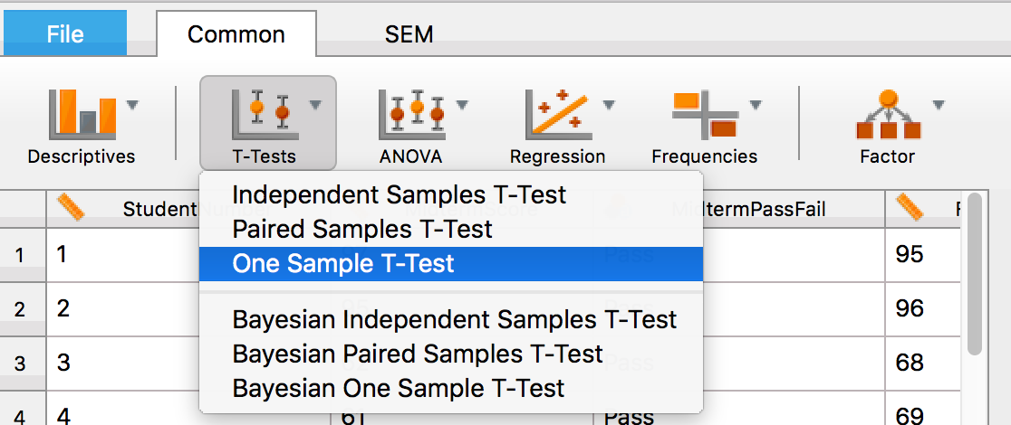

- Move the variable “MidtermScore” into the box on the right because that is the variable you want to analyze and compare to a greater population.
- Make sure you add the “Test value” of 72 in the appropriate box on the left to tell JASP that the population mean that you are comparing against is 72! If you leave the Test value box empty, JASP will compare the variable of interest to a mean value of 0, which we are not interested in.
- Select the appropriate “Hypothesis.” Here instead of writing µ they write “Test value” to be broader. The first option with the not-equal sign, means you’re running a two-tailed test. The > sign means you are running a one-tailed test to see whether your sample is greater than the test value (the population mean) and the < means you are running a one-tailed test to see whether your sample is less than the test value (the population mean).
- Finally, click the “descriptives” box so you get these descriptive data for your analysis.
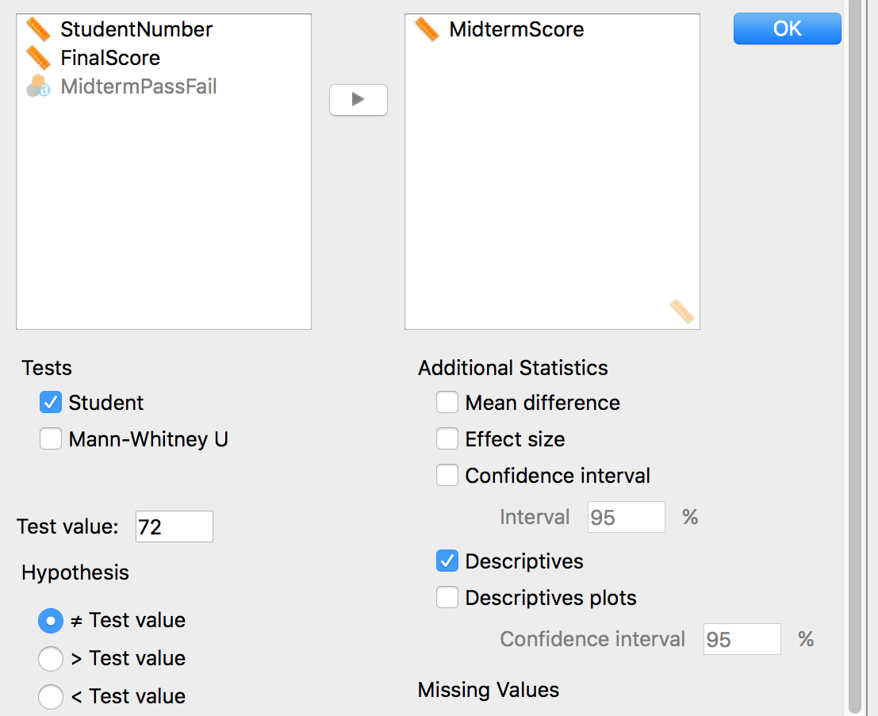

f. Report the results in statistical form:
To report and interpret your results using APA formatting: t(df) = test statistic value, p = __. Some help:
- Write the symbol for the test statistic (e.g., t), always italicized
- Write the degrees of freedom (for a one-sample t-test, this is the sample size, minus one; n - 1), in parentheses.
- Enter a space, then an equal sign, then another space, and then the value of the test statistic, typically to two decimal places.
- Type in a comma, enter a space, the letter p (always italicized), another space, equal sign, another space, and then the exact p value, typically to three decimal places, associated with the test statistic.
- Statistic typically follows a statement about the finding, after a comma or in parentheses. The report would also include the sample mean and standard deviation.

__________________________________________________________
g. Does the sample fall within the critical region (i.e., the tails)? | ☐ Yes ☐ No
h. Should the instructor conclude that this class performed differently on the exam than past classes? | ☐ Yes, reject the null  ☐ No, retain the null
i. Report the results in statistical AND written form:

Example response for this problem: It appears that midterm exam performance of students in this physics class is similar to midterm exam performance for students who took the course during the previous year. There was no significant difference in overall mean scores on the Physics midterm between current students (M = ___, SD = ___) and previous year’s students (M = __), t(__) = ___, p = ___.

Write your report of the results below:

PART C: Try It on your Own
Use the NormTemp Data file to test the research question below.
1. | Imagine I want to know whether this sample’s AM temperature differs from the population average AM temperature of 98.6°F.
 | a. State the Null and Alternative Hypotheses:
 | H₀:
 | H_{A}:
 | b. What variable/s are you including in your analysis?
 | Variable/s:
c. Is the hypothesis:
☐ non-directional ☐ directional

 | d. What test should you use? (be specific!)
e. Which of the following did you select when running your analysis?
☐ ≠ ☐ > ☐ <
 | f. Please copy the information from your output:
 | g. Report your results below in APA style sentences.
 | h. What is your decision regarding H₀? |  | ☐ Reject the null hypothesis ☐ Fail to reject the null hypothesis

2. Another Analysis using the Pizza data
Use the Pizza Data for to answer the following research question:

In addition to price, this data also includes a record of how cheesy the pizza was (Full disclosure: this column of data is fictional because our Pizza Nerd did not actually rate the slices in this way and I made up the data for us) on the following five-point scale.
0 (No cheese)
1 (Spotty, minimal cheese covering)
2 (Spotty, moderate cheese covering)
3 (Full covering of cheese)
4 (Extra cheesy)

Another pizza lover wants to know if pizzerias in this sample, on average, tend to have a full covering of cheese.

Think through this:
1. “We are comparing _______________________________ to ______________________________.”

Use this knowledge to answer the following:
- Write out the null hypothesis.
- Write out the alternative hypothesis.
- Which best describes the alternative hypothesis? |  |  |  | It is: ☐ Two-tailed ☐ One-tailed
c. Is the hypothesis: ☐ non-directional ☐ directional
- What test should you use? (be specific!)
- Which of the following did you select when running your analysis?
☐ ≠ ☐ > ☐ <

3. Another Analysis using the Pizza data
Use the Pizza Data for to answer the following research question:

The Pizza Principle proposed in 1980 argues that the price of a plain slice of pizza in NY typically matches the prices of the NYC subway fare. The current NYC subway fare for a single ride is $2.90.

Test whether the Pizza Principle is holding up in 2023.

1. | Test the Pizza Principle using current pizza prices and the current NYC subway fare of $2.90.
 | a. State the Null and Alternative Hypotheses:
 | H₀:
 | H_{A}:
 | b. What variable/s are you including in your analysis?
 | Variable/s:
c. Is the hypothesis:
☐ non-directional ☐ directional

 | d. What test should you use? (be specific!)
e. Which of the following did you select when running your analysis?
☐ ≠ ☐ > ☐ <
 | f. Please copy the information from your output:
 | g. Report your results below in APA style sentences.
 | h. What is your decision regarding H₀? |  | ☐ Reject the null hypothesis ☐ Fail to reject the null hypothesis

Part D.
Start working on your How-To sheets. Think about the following:
- How do you know that you need a Z-test for the first analysis and a One-Sample T-test for the second analysis? What’s the difference in the information you have?
- How do you know what type of hypothesis you’re testing (two tailed or one-tailed: greater than or less than)?
- How do you know what “Test Value” to use when you run a One-Sample T-test?

